Great Ballistics on the Cheap
By Bud Bertino

How to produce bullets (projectiles) with perfect lands and grooves for ballistics comparison

Note: Students work with spent ammunition only and no firearms.

Teacher Preparation:

You want to produce some perfect sets of bullets with no deformations for use in forensics class. You saw the Myth Buster’s Episode (#34) “Bulletproof Water.”

A short version is at https://www.youtube.com/ watch?v=yvSTuLIjRm8
A long version is at https://www.youtube.com/ watch?v=L-VOfpUlqyE or https://www.youtube.com/ watch?v=iPJWTuiNVyQ or
a text summary is available at http://www.discovery.com/tv- shows/mythbusters/mythbusters-database/water-bulletproof. htm

You feel excited about asking your next door neighbor’s permission to shoot into his pool for the perfect specimens you need for a ballistics lab activity. This type of shooting would be a BIG mistake for a number of reasons! Here is an alternative you might consider.

The Background:

I was fortunate to have access to a firing range. If you’re not a shooter yourself, find someone who is to help you. Do a Google search for gun shops or gun ranges in your town
or city, call and explain who you are and why you’re seeking guidance, and you’ll find a helpful soul. My partner, Tom Milner is a certified NRA instructor. He was enthusiastic about working on this project with me, and helping insure the
safest of conditions.
bullet. Our unsuccessful approaches included shooting into columns of water and lined up jugs of water. We succeeded in learning a lot about how these approaches were NOT going to work.
We moved on to a new plan. I shot into a two foot long array of phone books. This worked fine in stopping the bullets, but the projectiles were often flattened and far from perfect.
We thought we might be able to slow the bullet without destroying it by using polyester fill used for home insulation.
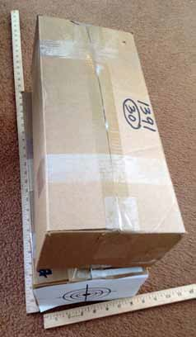
Tom purchased a 10 lb. box
of Poly-fil®. I tightly packed
the Poly-fil® into three small boxes (see below) and taped them shut. At the range, three boxes were lined up end to end
so that I would be shooting at the target end of the first box (see
photo below). We had no idea how far the projectiles would penetrate.

This technique worked! The
.22 caliber and
9 mm bullets

We tried several approaches to producing the perfect
Shooting boxes. Note target on the end of the white box.
we recovered

were perfect. They had melted the Poly-fil® as they traveled through the first box and into the second. By checking the back end of each box we could determine if the bullets had passed through and determine where to look for them. The key to success was in the tight packing of the boxes. The results are pictured below.

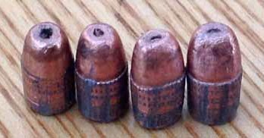
.22 LR bullets.

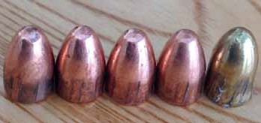
9 mm bullets – notice Poly-Fil® still adhering to the brass bullet on the right.

Teacher Notes for the Activity: Class size 24

Materials: (Per two students)

- 3 Spent bullets (.22 from rifle, .22 from pistol, 9 mm from pistol)
- Marking pen
- Flash drive with rotating cover protector
- Hand lens or dissecting microscope
- Calipers
- Super Blue® (available at Sears.com or Amazon.com or lots of other places; Google it.)

Part 1. Finding evidence on the bullets

- Determine caliber of each cartridge using calipers to measure the width of each projectile and record their results in a table you provide.
- Determine the number of lands and grooves. Mark the first projectile with a marker or pen at any land. This will help with the count. (The number of land and

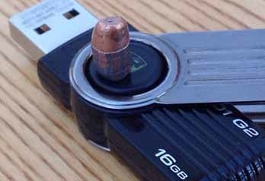
Flash drive used as a rotating viewer for counting lands & grooves.

grooves will be the same.)
Using a flash drive as a pedestal and a hand lens or dissecting scope, count the lands & grooves as you rotate the bullet. Record your count.
- Record whether the grooves spiral left or right.
- Using the Internet, reference the firearm that might have been used from a list provided by instructor. http:// www.forensictechnology.com/FRT/
- If you want to add additional math, have students measure the widths of the lands and grooves and research and compare information from different firearms manufacturers.
Reference article of interest to get you started: http://www. pochefamily.org/Books/RimfireBullets.htm

Part 2. Lifting Fingerprints from Shell Casings

Premise for your scenario: Shooters leave fingerprints on cartridge casings when they load their firearms. While at the firing range, collect shell casings for use in the following fingerprinting exercise:
Notes on Materials:

- Spent shell casings from a firing range. A Google search will show you the closest one. The easiest casings to use will be the larger center-fired casings. Most ranges have hundreds on the ground or in bins provided for discard or recycling.
- Using Windex® (or a similar mild cleaner) and wearing gloves, spray and wash the surfaces of each shell casing to remove all fingerprints.
- Place a fingerprint on each shell casing and store in a paper bindle or coin envelope.
- Prepare a solution of Super Blue®. Caution: Super Blue® is used to protect a firearm from rusting. It is caustic and should be handled carefully using goggles and gloves. Dilute 20 ml of Super Blue® with 5 ml of

water and store is a closed container. This is your stock solution.
- Syracuse dishes (or watch glasses)
- Plastic forceps (missing from photo)
- Paper towels

Procedure: (develop your own scenario as you see fit)

- Provide each pair of students with two shell casings prepared by instructor.
- Describe your scenario about a shooting and the finding of shell casings at the crime scene with possible fingerprints.
- Have students fill a Syracuse dish (or watch glass) with Super Blue® solution and, using plastic forceps, dip the shell casing for a few seconds and watch the fingerprint develop. Remove from the Super Blue®
solution and rinse thoroughly. Place on paper towel to air dry.
- View, photograph, sketch, and describe the ridge pattern detail of the fingerprint.
- You can use Super Blue® on other metal surfaces but it will eventually corrode them. I used it to photograph a fingerprint on a quarter.

Additional teaching tips and ideas to explore can be found at
www.bertinoforensics.com

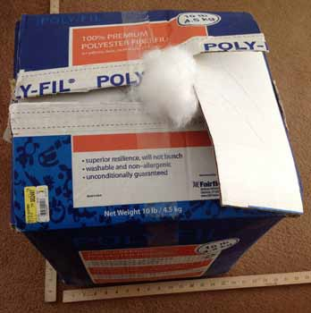
10 lb. box of Poly-Fil™.
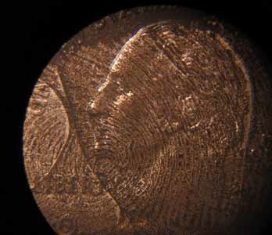
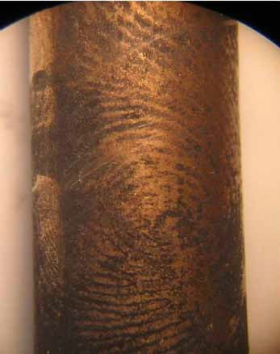
Fingerprint on shell casing.

A fingerprint on a quarter.
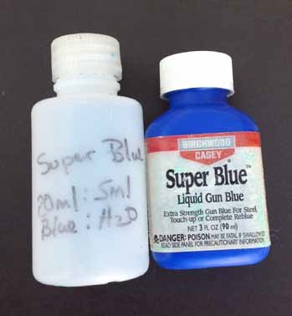
Super Blue® solution.

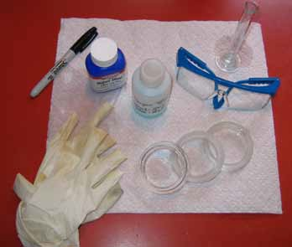
Super Blue® materials

